1.0 Install Hyper-V by **powershell**

**NOTE:**To install hyper-v in powershell you will need to go to the CLI server directory folder and add the following command

**CPUID.V0="FALSE"**

Change **guestos ="WinHyperV'**

2.0 Enable Remote Access[ Other users with RDP can connect to your server]

3.0 Install on a Windows 10 [separate machine] Windows Admin center [ require internet]

4. Connect to your CLI [core server]

5. Create a new Folder called ISO into C:\

6. Add a win10.ISO into the ISO folder

7. With WAD create a Win10 virtual machine

8. With 1-2 GB of RAM [note you might need to add 6 -8 GB to your CLI server]

9. With 30 GB of Storage

10. RDP into the Server to ensure it function

1.0 PS of Hyper is installed by powershell

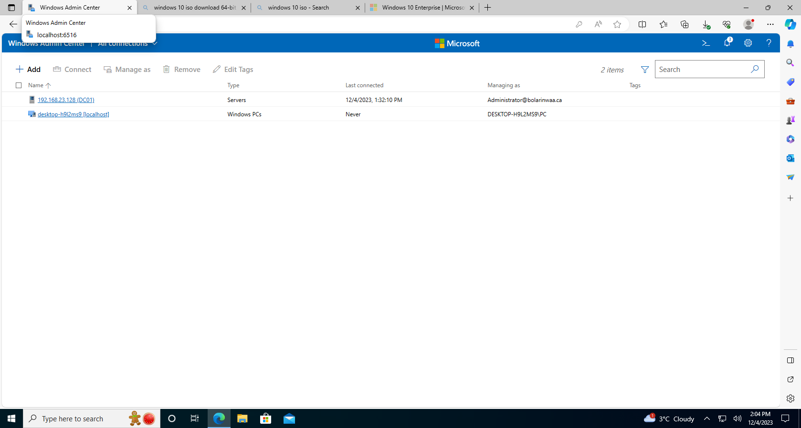2.0 PS of WAD is running

3.0 PS of ISO file is uploaded into**C:\ ISO**

**4.**PS of a new WIn10 VM is created by powershell

5.0 PS that you can remote into the newly created VM

**Theoretical part**

1. What is the purpose of virtualization [150-200 words]

Virtualization is a technology that enables the creation of virtual versions of computing resources, such as servers, storage devices, or networks. The primary purpose of virtualization is to maximize the efficiency, flexibility, and utilization of hardware resources while minimizing costs. By abstracting the underlying physical infrastructure from the software that runs on it, virtualization allows multiple virtual instances or environments to coexist on a single physical system.

One key benefit of virtualization is server consolidation, where multiple virtual servers run on a single physical server, reducing the need for additional hardware and lowering energy consumption. This improves resource utilization and simplifies management. Virtualization also enhances scalability, as additional virtual instances can be easily created to meet changing workload demands.

Moreover, virtualization facilitates the efficient allocation of resources, enabling isolation between different applications or workloads. It provides a foundation for cloud computing, enabling the rapid deployment and scaling of virtualized resources. Additionally, virtualization enhances disaster recovery and testing capabilities by encapsulating entire virtual machines, making it easier to replicate, move, and recover them in case of failures.

2.0 Difference between Type 1 and Type 2 virtualization [100-150 Words]

Type 1 and Type 2 virtualization refer to different approaches in implementing virtualization.

Type 1, also known as bare-metal or native virtualization, involves running a hypervisor directly on the physical hardware without the need for a host operating system. This hypervisor controls and manages the virtual machines, providing better performance and resource utilization. It is commonly used in enterprise environments for server virtualization.

Type 2, or hosted virtualization, relies on a host operating system to run a hypervisor as an application. This additional layer between the virtual machines and the physical hardware can introduce some performance overhead. Type 2 virtualization is often used for development, testing, and desktop virtualization scenarios.

3.0 What is the purpose of hypervisor [100-150 Words]

The primary purpose of a hypervisor is to enable virtualization by managing and allocating resources on a physical machine to multiple virtual machines (VMs). Acting as a layer between the hardware and the operating systems of these VMs, the hypervisor abstracts the physical infrastructure, allowing multiple operating systems to run concurrently on a single server. This abstraction enhances resource utilization, as multiple VMs can share the same physical resources, such as CPU, memory, and storage, while remaining isolated from one another.

Hypervisors play a crucial role in creating virtual environments, facilitating server consolidation, efficient resource allocation, and improved scalability. They also contribute to increased flexibility in managing workloads, as VMs can be easily created, moved, and scaled to adapt to changing demands. Overall, hypervisors are fundamental components in modern virtualization technologies, enabling the efficient use of hardware resources and supporting the development of cloud computing environments.

4. What is the purpose of HAL [100-150 Words]

The Hardware Abstraction Layer (HAL) serves as a critical component in computer systems, acting as an intermediary layer between the hardware and the higher-level software, such as the operating system. The primary purpose of the HAL is to abstract and isolate hardware-specific details, allowing the operating system to be more hardware-agnostic. This abstraction facilitates greater portability of the operating system across different hardware platforms.

By providing a standardized interface to the underlying hardware, the HAL enables the development of operating systems that can run on diverse hardware configurations without requiring extensive modifications. This abstraction simplifies the process of writing and maintaining operating system code, as developers can focus on interacting with the HAL's standardized interface rather than dealing with the intricacies of individual hardware components. Overall, the HAL contributes to improved flexibility, portability, and ease of development in the realm of operating systems.